Home Learning: Chestnut Class

We are adopting a flexible approach to home learning at Hadlow Primary School. We are breaking home learning into three categories: essential, recommended and optional.

Essential (Supported)
These tasks are expected to be completed weekly. They are core areas of learning that underpin academic progress and success.
Reading   | Please keep reading regularly with your child and remember to record it in your child’s reading record. Children should be reading at least 5 times per week.  Please use the suggested question scaffolds to support your child with comprehension questions, to develop and enhance their understanding.  https://primarysite-prod-sorted.s3.amazonaws.com/hadlowprimary/UploadedDocument/0fac17db-a4ee-4b02-afac-ce25ce44ae4f/reading-threads-ks2-questions.pdf  Printed copies available on request.
  Spellings | Please continue to support your child with learning their weekly spellings. Spellings will be provided for the term ahead. Children will be challenged on these words weekly.  Use the spelling ideas on the school website to make this fun and memorable for your child.  https://hadlowprimary.secure-primarysite.net/english-66/

Recommended (Independent)
These tasks are designed to be completed in small chunks, as often as possible. They will support your child to be successful within the classroom.
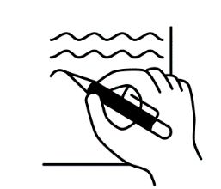  Handwriting | Encourage your child to use the interactive tools on Letter Join to practise handwriting precision.  https://www.letterjoin.co.uk/  Alternatively, ask your child to collect a handwriting practise sheet from the classroom.
Maths  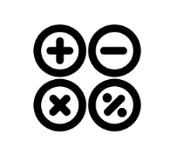 | Set some time aside for your child to have fun whilst learning through the TT Rockstars platform. https://ttrockstars.com/  Times tables underpin most mathematical concepts. Having the ability to fluently recall these number facts will support your child in all areas of the Maths curriculum.

Optional
These activities are optional. Children are not expected to provide evidence of completion, but may wish to do so if they are proud of their learning. These tasks are designed for families that have time and capacity to delve further into the curriculum. These tasks will be updated termly, and will link to previously taught curriculum topics. This will help to consolidate and retrieve learning.
Term Six
Explore   | Let’s explore Italy!  Pretend you are a food critic! Develop your vocabulary by choosing a dish commonly eaten in Italy. Make your chosen dish and then write a review.  Say what you liked about it, didn’t like about it and what could be improved.  Don’t forget to use descriptive language and take lots of pictures along the way.
  Discover | In Science, we are learning about animals including humans.  Research all about your teeth. Gather all the key information about caring for your teeth, the purpose of each tooth and how they might be different to other animals teeth.  Present your findings in a poster, the more creative the better.  Use colours, pictures, flaps and even 3D models if you would like. Allow your creative juices to flow while you learn.
  Create | Get creative and have some fun!  Please create a picture, prop or model to accompany our Bella Italia topic e.g the coliseum, the Leaning Tower of Pisa, the Trevi Fountain– anything at all!  Don’t forget to take some fantastic photos!



